Miracles Group  No 17, 295 Bach Mai, Hai Ba Trung, Ha Noi, Viet nam  P: +84 383396560  Email: help@miracles.vn  Website: https://miracles.vn/  Invoice 27102020 | 

To | Date
Jérôme Lille (LIJE Creative) | July 26, 2020  Payment method:  Paypal
Project: megaclass.online
# | Description | Unit Price(Euro) | Total
1 | Coppy New |  | 45€
 |  | Total Due By 7.26.2020 | 45€
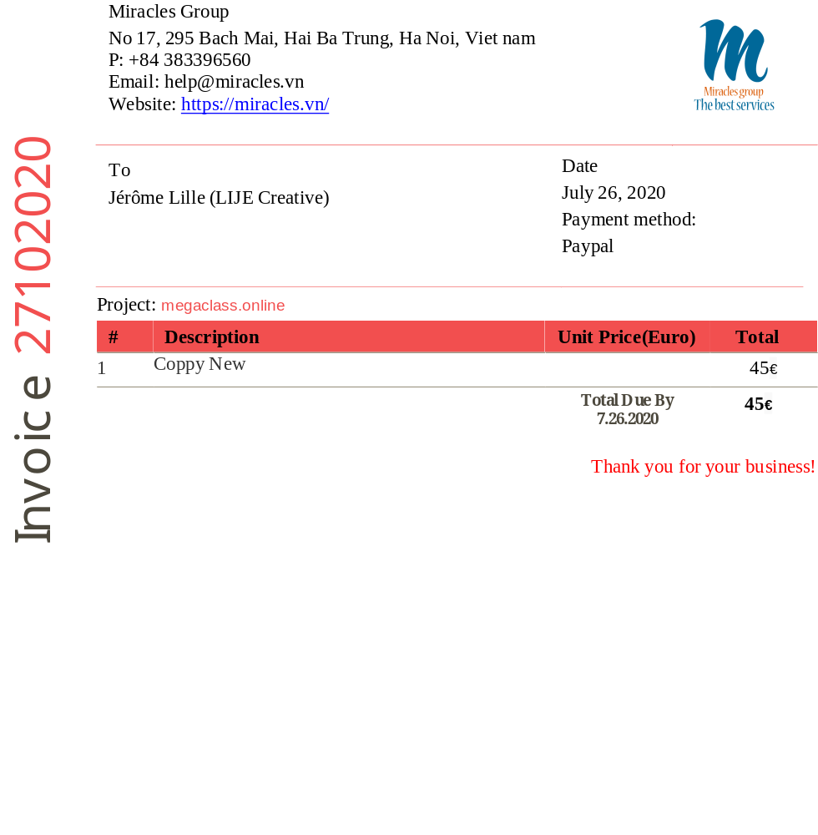Thank you for your business!

